The Five Areas of our Life and Mission Together  CrossWay is a Union Church with our roots in both Methodist and Presbyterian denominations. However we come together first and foremost as CrossWay Church; a unity of people from all kinds of denominations, backgrounds and cultures. Jesus bursts the bonds of a divided world, and we value bringing together people whom society often separates or even excludes – just as Jesus did in the bible and continues to do so today.  To help us plan and evaluate where we are in our response to God’s mission, we look at five key areas of our church life here at CrossWay. A brief description of these areas, including our key values, are outlined in this booklet.  Our Contact Details  CrossWay Church Locations:  Cnr Queen Street and Worksop Road 1a Totara Street, Lansdowne  PO Box 789 Masterton 5810  Get in Touch:  crosswaychurchmasterton.org.nz  crosswaychurchmasterton  Minister: Rev Daniel Yeazel Phone: 021 0828 9071 or 377 3627  Email: DanYeazel@gmail.comz  Parish Administrator: Judith Harris Phone: 378 6152  Email: enquiries@crosswaychurch.org.nz  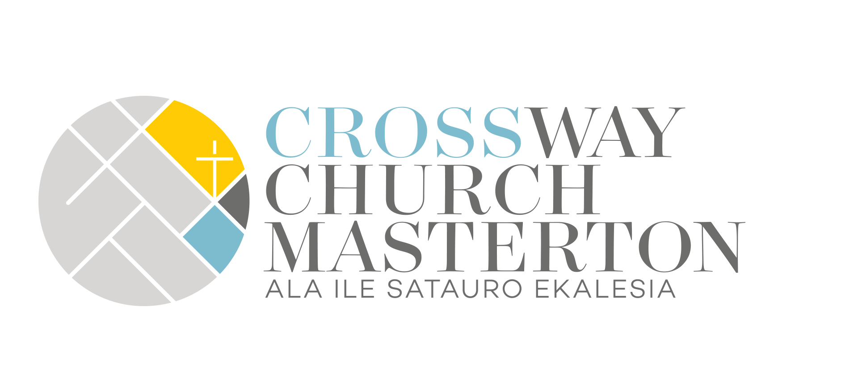  Chairperson: Robin Dunlop Phone: 378 6628 |  |  | Making Christ Visible in Our Community  our mission plan: what we are focusing on from 2020 to 2022  This booklet briefly outlines what we’re focusing on at CrossWay Church from 2020 through to 2022. It outlines what we are dedicating our people and resources to in our response to God’s mission.  The church is unique in that its vision and organisation is shaped and equipped by God. However we, as God’s people, also shape the unique values and qualities of our church community, since the church also reflects our diverse cultures, backgrounds and community.  In this booklet you’ll find an outline of our aspirational values and objectives that reflect what we hope to achieve in five key areas of our church life; our worship services, our development as disciples of Jesus, our fellowship or investment in each other lives, our evangelism (sharing the good news of God) and finally our public witness and social justice activities.  It’s our hope that in reading and praying through this booklet, you’ll gain some insight into what God is doing with us and through us, for this time and place.  Please join us on this exciting journey in Making Jesus Christ visible in our community.  [Company Name]  [Subtitle]

at our heart and life is god’s mission  God wants to be known! For Christians, the nature and being of God is uniquely revealed in Jesus Christ of Nazareth. In the Gospel of John, Jesus says ‘If you know me, you know the Father’ (John 14:7). It is in this unique revelation that we find our purpose and being as God’s people or church. We know, through the actions and being of Jesus, that God is a God-of-Love and that God is a God-for-People. This is the heart of the Good News that Jesus declares right at the beginning of his public ministry nearly 2000 years ago.  Since then, God has been calling and commanding the church to be the first-fruit of this good news. As God’s people, our primary mission is taking the good news of Jesus into our hurting world. God does this by setting us apart to be a sign or pointer to the new way of being human together. As God’s people, we are blessed, loved, restored and renewed, and then sent out into God’s world. God calls us to be ‘salt and light’ (Matthew 5:13-16) to individuals, families or whanau and communities.  We are a Missional Church; we are God’s people with God’s mission at our heart and our life together in and for God’s world!  our mission field in masterton  In the 2013 Census survey, our population in Masterton is just over 23,000 which comprises of around 9,600 households. Nearly 70% of our households are made up of one family (about 15% are single-parent with dependent children), and around 24% of them house one person. Our median age is around 42 years old and nearly 20% of our population is under 15 years old.  We also have a collection of different races and cultures living here. Around 86% identify as Pakeha or European, 18% identify as Maori (this includes people who identify as both or more, so the percentages add up to over 100%), around 5% identify as Asian or Pacifica, and the remainder come from countries such as Africa, Latin America or Middle East.  This is our community whom we are God’s salt and light in and to! |  |  | Our Evangelism (Sharing the Good News of God)  At its heart evangelism is about ‘turning around’ in our relationship with God. It involves turning away from a life characterized by separation from God or our unfulfilled potential in God’s image, and turning toward a life where we are restored through Jesus into the life and love of our Trinitarian God. God wants us to be free and have fullness of life (John 8:36 and 10:10)! God calls the church to make this good news known to all people, through our lives, our choices, our behaviour and words.  Below are our objectives against two aspirational values we are focusing on at CrossWay Church:  We value creating spaces where Christians and non-Christians meet together to develop ‘God-Thinking’. Our key objectives in helping us achieve this value include:  - Offer regular opportunities to explore key topics that are relevant to social justice, life values and ethics.  - Run at least one Alpha course each year  We value equipping members of CrossWay in sharing their faith. Our key objectives in helping us achieve this value include:  - Appoint an Evangelism Coach – someone who has a passion for sharing God’s good news. This person will walk alongside and enable our corporate and individual life in evangelism by offering training, and support our corporate-evangelistic efforts (such as seminars or Alpha)  - Continue to invest in rest home visits and offering worship services
1 |  |  | 6

our public worship  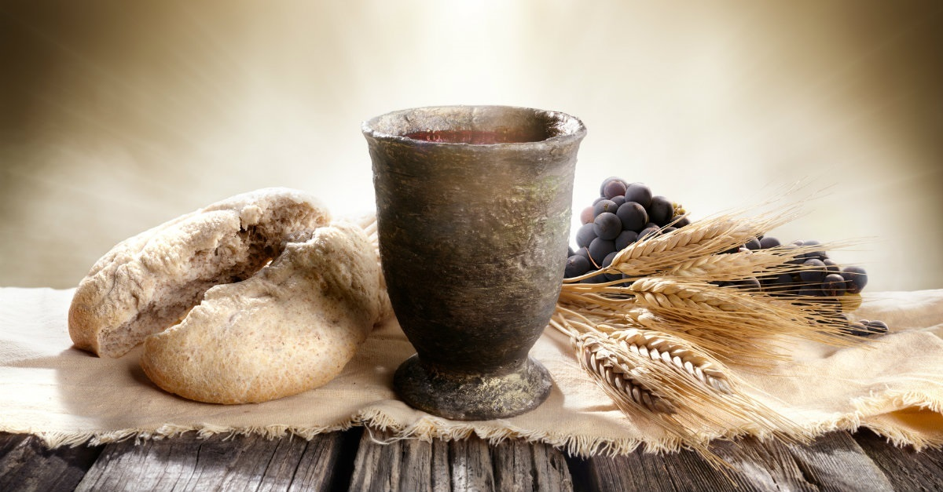  Every time we gather together as members of God’s family to hear and experience the gospel in our services, we are invited to respond anew to God’s call in Christ. In our public worship, God renews us, heals us, blesses us and then sends us out into God’s world.  Below are our objectives against two aspirational values we are focusing on at CrossWay Church:  We value gathering together as one family under our Triune God. Our key objectives in helping us achieve this value include:  - Join the three ‘separate’ congregations (Presbyterian, Samoan Fellowship and Union) to worship together at Queen Street, with our English-language service at 10.00am and our Samoan-language service at midday  - Broadcast our Worship services on TV and Radio.  - Open up the 10.00am service to incorporate creative worship for children, youth/young adults and Samoan-language songs and hymns, and encourage members to express their unique creative gifts  - Provide resources for children during public worship that will cater for their unique needs and learning styles through the leadership of the Children’s Community Ministry role (refer our Public Witness objectives for more information on this role) and existing Samoan youth and children church leaders  - With the Children’s Community role we will be Kids Accredited under PCANZ (see https://www.presbyterian.org.nz/national-ministries/kids-friendly)  We value table fellowship for its intimacy.  - Continue to offer café services in Queen Street Hall, |  |  | our public witness  The mission of God goes right to the heart of humanity and takes up our cause in times of need or distress. God desires justice, dignity and restoration of relationships for all people. Our public witness at CrossWay starts with those who often experience being furthest away from God’s love and providence.  Below are our objectives against two aspirational values we are focusing on at CrossWay Church:  We value partnering with other organisations who work with vulnerable people and struggle for social justice  - With the support of grants, we will create a Children’s Community Ministry role who will work closer with Masterton Family Education & Support Centre (MFESC) to deepen missional and evangelical opportunities. They will also explore further opportunities with other vulnerable-children-based organisations within Masterton.  - With the guidance of the Children’s Community Ministry person and MFESC, we will look for opportunities to train and mentor people to work alongside vulnerable families  - Offer opportunities to partner with specialists or leaders from social justice-based organisations to speak or seminars or public worship events  We value creating space for people to share about their work and engagement with social justice (including care of creation)  Create spaces in our public worship or seminars for people to share about their work and/or engagement with social justice
5 |  |  | 2

our discipleship development  We don’t expect people to know instinctively what it means to be a disciple of Jesus. Jesus calls his church, and especially teachers, coaches and leaders, to support and equip people in their development as Christians.  Below are our objectives against two aspirational values we are focusing on at CrossWay Church:  We value new and existing members being introduced to the Mission of God and CrossWay Church  - Set up and equip a Discipleship Development Coach who has a passion for enabling and equipping people’s development in Christ.  - Offer an introductory course to all existing members, refreshing them on the Mission of God and our response as CrossWay, our key values, and our objectives  - Offer new members the same introductory course, and a modern catechumenal course (such as Alpha) to help them in their initial development as followers of Jesus  We value small groups as a structure for enabling our discipleship development  - Offer training for more leaders and coaches to set up and lead new small groups  - With new small group leaders, we will set up a variety of different small group structures with the intention of encouraging all members to join a small group that meets during the week |  |  | our fellowship together (outside of public worship)  God calls us to be a new family. Just as we invest in sharing our home lives with siblings, parents or other family members, we are also called to share our lives as brothers and sisters of Jesus. This means prioritizing and making space to be with each other. In this way, we show our love for one another just as Jesus commands us (John 13:34).  Below are our objectives against three aspirational values we are focusing on at CrossWay Church:  We value our pastoral care system and making sure no one misses out  - Set up and equip a Pastoral-Care Coach who has a passion for pastoral care, and equipping others in pastoral care. We will support them in equpping the pastoral care team in coaching and training – especially in acute-care situations  - Create opportunities for our pastoral care to be celebrated in our public worship, as well as including more information on it on our weekly newsletter  We value fostering deeper friendships with and among our children and youth  - With the support of our Children’s Community Ministry position, and our Samoan Children and Youth Leaders, we will build new fellowship structures and events that unite our youth and children in fellowship outside of public worship  We value seeing conflict as an opportunity to enrich relationships  - Offer teaching on managing conflict lovingly and biblically, including putting together a booklet that sets out our expectations and processes on conflict management and resolution at CrossWay Church
3 |  |  | 4

